**Lakewood Belmar Team**

**Jamie Ortiz, PT, DPT**

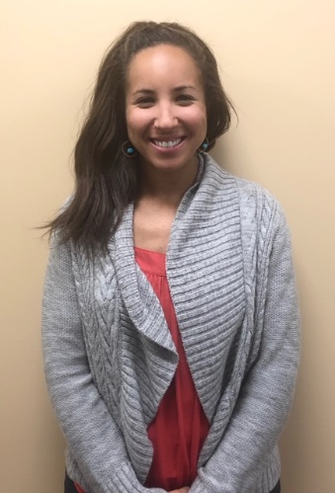Jamie earned her Doctorate of Physical Therapy from the University of New England in Portland, Maine in 2014. She received her undergraduate degree from Colorado State University where she majored in Health and Exercise Science with a concentration in Sports Medicine. Jamie has focused her PT career in outpatient orthopedics and has had the opportunity to work with a variety of injuries and patients of all ages. She enjoys educating patients regarding their injuries and uses the most up to date evidence based treatments to make sure her patients return to the activities they love as quickly as possible. In her free time, she loves to hike mountains, trail run, mountain bike, and camp with her husband and their twin boys.

**Reba Havis PT**

Reba Havis grew up in Fort Collins, CO and went to Poudre High School. She enjoys Colorado’s expansive outdoors by hiking with her dogs, rock climbing, and mountain biking. She went to the University of Florida for her undergraduate education and received her Doctorate of Physical Therapy from Northeastern University in Boston, MA. Reba joined the Panorama Team in 2021 following the completion of her education. She treats various conditions of the musculoskeletal system, but takes special interest in chronic pain, hip conditions, and pelvic health.

**Allison White PT**

Allison was born and raised in Colorado. She received her Doctorate of Physical Therapy from CU Anschutz School of Medicine. She received her undergraduate degree in Integrative Physiology from the University of Colorado Boulder. Allison played lacrosse in college as a goalie and now coaches high school girls lacrosse. She also plays Australian Rules Football. Having endured many surgeries, herself she is passionate about treating patients recovering from surgery and helping athletes return to sport. She is certified in dry needling. In her spare time, Allison is a loyal CU Buff fan and attends as many games as possible. You will always find Allison in a cool pair of sneakers.

**Noah Hammer, PTA**

Noah grew up in Lone Tree, CO, where his love for running blossomed into a variety of sports through high school and college. He attended the University of Wyoming, where he graduated with a degree in Urban Studies and Regional Planning. After quickly realizing that the computer life was not for him, he followed in his little brother’s footsteps and pursued a career in physical therapy.

Noah earned his PTA certification from Pima Medical Institute and has been with Panorama PT since February of 2024 (and never looked back). He takes a special interest in proprioceptive manual techniques and patient-centered treatment options, in order to progress each client back to their specific goals.

In his spare time, Noah enjoys the pleasantries of what the mountains have to offer, such as skiing, hiking, fly-fishing, and camping.

**Fred Rooley, PT, DPT**

Fred earned his Doctoral of Physical Therapy from Northern Illinois University, NIU) in 2019.  His bachelor’s degree of General studies was received in 2005 from University of North Dakota, UND.  Fred’s approach to therapy is a holistic with a focus in evidence-based practice.  He enjoys working with a wide range of orthopedic conditions while working towards functional improvements and return to recreational activities for improved quality of life.  In his spare time Fred likes to camp, hike, fish, ski, exercise, yard work, and read a good book.

**Kylee Henderson, PT**

Kylee grew up in Bloomington, Indiana and stayed in town to attend Indiana University and major in Exercise Science. She then received her Doctorate of Physical Therapy from the University of Dayton in Ohio. Throughout her schooling, she was involved in coaching soccer, where she developed a passion for adolescent sports, injury prevention, and return to sport rehabilitation. Since moving to Colorado and joining the Panorama team, she has enjoyed treating a variety of musculoskeletal injuries, is a member of the foot and ankle team, and is a member of the community service group. Her favorite part about being a physical therapist is building relationships with patients and helping them get back to whatever they love to do. Outside of work, Kylee loves to play soccer, mountain bike, trail run, and ski.

**Natasha Evans, PT, DPT**

Natasha received her undergraduate degree in Economics and Spanish from Syracuse University and completed her Doctor of Physical Therapy degree at Boston University in 2013. She grew up in New York and has a background in competitive gymnastics. Natasha’s love for skiing brought her to Colorado where she worked as a ski instructor in Vail. Natasha joined Panorama Physical Therapy in 2017 and is dedicated to providing outstanding, individualized patient care with an emphasis on manual therapy, functional mechanics and patient education. In her free time, she enjoys spending time with her husband and two little girls, skiing, rock climbing and traveling.