**Orchard Team**

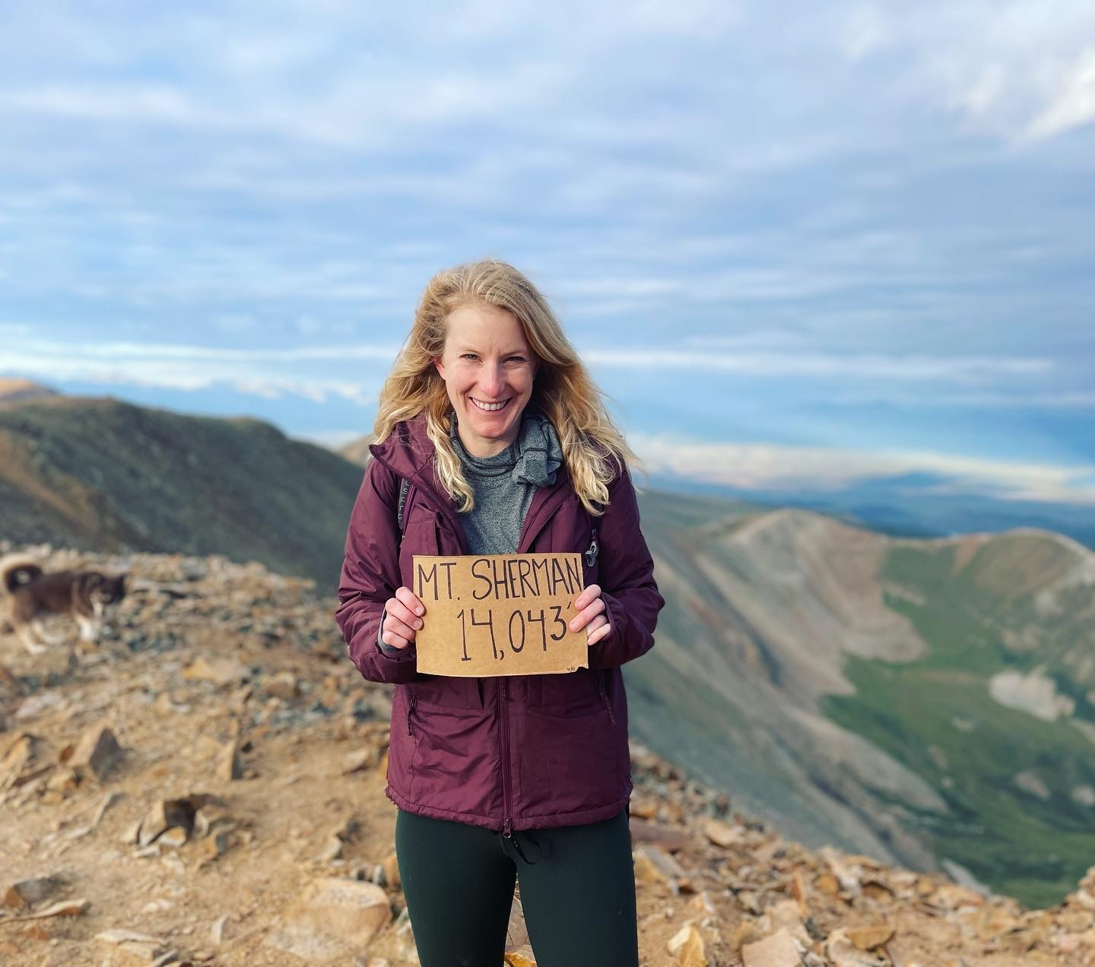**Emily Groff PT, Clinic Director**

Emily was born and raised in Dallas, Texas and attended the University of Oklahoma for her undergraduate studies. Emily completed her PT school education at Texas Woman’s University graduating in 2018 with her Doctor of Physical Therapy. Following PT school, Emily moved to Colorado. Emily has been practicing in the orthopedic setting for the past 6 years joining the Panorama team in 2021. She is a Certified Dry Needling Specialist and a Certified Sports and Conditioning Specialist. Emily specializes in treating hip pathologies, having 2 hip surgeries herself, but treats a wide variety of diagnosis. When not working, she enjoys hiking, snowboarding, and playing with her dog Winnie.

**Trenna Olson PT, Lead Therapist**

Trenna studied Biology with an Emphasis in Pre-PT at Grand Canyon University and received her Doctor of Physical Therapy from Northern Arizona University in Flagstaff, AZ in 2019. Trenna started her professional career in Tucson, AZ working for 2.5 years in an Outpatient Orthopedic setting before making the move to start a new adventure in Colorado. She is Level 1 Dry Needling certified and believes a physical therapy program should be individually tailored and address all aspects of a patient’s life to help them reach their fullest potential. In her free time Trenna enjoys being outside exploring, hiking, trail running, camping, and spending time with family/friends.

**Morgan Wilcox PT**

Morgan grew up in Northern Colorado and received her Bachelor of Science in Exercise Science and was a collegiate softball player at Colorado Mesa University in Grand Junction. Morgan earned her Doctor of Physical Therapy degree from the University of Colorado, Anschutz Medical Campus in 2020.

Morgan has been practicing in the orthopedic setting for the past 3 years and most recently became certified in Functional Dry Needling Level 1. While she likes utilizing her sports background for return to sport rehabilitation in athletes, she enjoys seeing and treating all orthopedic conditions and strives to provide patient-centered care to every individual in order to help them reach their goals and return to doing the things they love.

Following PT school Morgan married her high school sweetheart, bought a home, and recently became a mom to a sweet baby girl! In her free time, she enjoys exercising in any form (most recently running half marathons) and spending time with her friends and family.

**Madi Kaufman PT**

Madi was born and raised in Southern California where she quickly realized she was not cut out for beach life. For a change of scenery, she moved north to Eugene to attend the University of Oregon (go Ducks) where her appreciation of nature and sports continued to grow. Madi then made her way to the East coast to attend Boston University, where she graduated with her Doctor of Physical Therapy in 2021. Following her last clinical rotation in Aurora, CO, Madi decided to stay and make Denver her home.

Madi has been with Panorama since September of 2021 and has since become certified in Functional Dry Needling Level 1 and has joined the Panorama Pain Neuroscience Team. Madi’s relaxed style helps her patients feel comfortable during treatments and she strives to build personal connections with each patient while helping them work towards their goals.

**Kamryn Klepper PT**

Kamryn graduated from Texas State University with a bachelor's degree in Exercise and Sports Science. She attended Franklin Pierce University in New Hampshire where she received her Doctor of Physical Therapy degree in 2024. After spending time in the Denver area for clinical rotations, she decided to return upon graduation to explore the mountains and treat a more active patient population. Kamryn enjoys helping patients with a variety of diagnoses return to the activities they love the most. In her free time, Kamryn enjoys hiking, camping, playing soccer, and drinking coffee!

**Emily Gee PT**

Emily Gee is a physical therapist and certified yoga instructor from Berkeley, CA.  She earned her Doctorate in Physical Therapy from the joint University of California San Francisco/ San Francisco State University program in 2018.  She continued her education in CO by completing the Regis University Residency in Orthopedic PT and became a board-certified orthopedic specialist in 2023 by the American Board of Physical Therapy Specialties. She also holds a certification in vestibular and concussion rehab from the American Institute of Balance and is dry needling certified. Prior to working at Panorama Emily was the lead PT for Synergy Health Partners in Aurora, CO, an interprofessional company specializing in the treatment of patients following motor vehicle collisions.  Emily is an active member of the American Physical Therapy Association (APTA) and the CO APTA chapter’s PT advocacy network.  As a former professional musician, she has a special interest in injury prevention and health and wellness for musicians.  Outside of Panorama Emily teaches yoga at Reunion TKD in Brighton, and enjoys hiking, playing music and spending time with friends and family.

**Nidhi Chigurupati PT**

Nidhi grew up in Alabama and earned her undergraduate degree in Biology from AUM before completing her Doctorate in Physical Therapy in 2019 from Alabama State University. Her professional journey began in Florida, and later moved to Colorado after marriage. Outside of work, her husband and her love discovering Colorado’s hidden gems, and her husband is working to get her into snowboarding.

**Hand Therapy Team**

**DeAnn German PT, CHT**

Part of the original physical therapy staff back in 2008 when Panorama Physical Therapy opened its doors, DeAnn German holds a BS in physical therapy from Mount St Mary’s College in Los Angeles (1991). After practicing for three years in California, DeAnn moved to Colorado in 1994. DeAnn relocated to Virginia in 2005 for a few years and then decided she did not want to live anywhere else and moved back to Colorado in 2008. She became a Certified Hand Therapist in 1999 and currently treats injuries of the shoulder, arm and hand, working closely with Panorama’s hand surgery service. DeAnn and her husband of 20+ years, Dave, live in their dream home just north of Denver. In her free time, DeAnn is a crazy horse lady who enjoys riding and working with a local equestrian vaulting team.

**Jenna Neff, OT, CHT**

Jenna was born in Lancaster, PA but relocated to Colorado from Washington, DC in 2022. She is an Occupational Therapist and Certified Hand and Upper Extremity Therapist. Continuing education and mentoring are of high priority; she has the mindset of a lifelong learner!

When not at work, Jenna enjoys all things outside, preferably in the sunshine. She continues to play competitive field hockey, though had to sit this season out as she and her husband are expecting their first child in July! Her 3-year-old dog, Zili is also very excited about this new development.