Centennial Physical Therapy

Emily Hoyt, PT, DPT, CMP, Cert DN
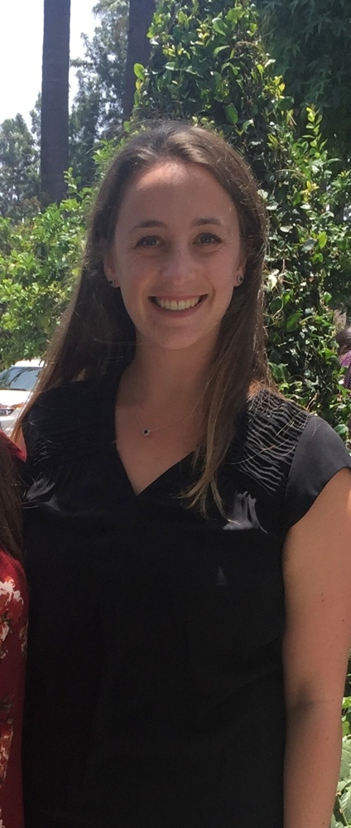
Emily grew up in Moraga California and completed her undergraduate degree at California Polytechnic State University where she received a Bachelor of Science in Kinesiology. She went to Azusa Pacific University for graduate school and received her Doctorate of Physical Therapy in 2017. Emily practiced in California before moving to Colorado in 2021. She enjoys hiking and skiing in her free time.

Connor Longacre, PT, DPT
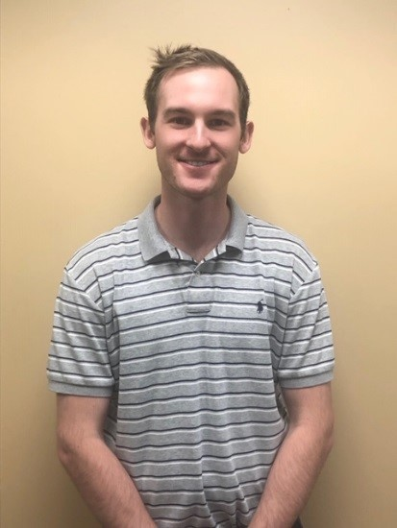
Connor studied Health and Exercise Science at Colorado State University, and achieved his Doctor of Physical Therapy from Regis University in Denver, CO in 2018. For two years, Connor worked in Silverthorne, CO, treating avid skiers, mountain bikers, and hikers, helping to rehabilitate anything from traumatic injuries to joint replacement surgeries. Connor is Level 1 Dry Needling certified, and utilizes manual therapy and exercise to achieve optimal results. On the weekends, he enjoys playing disc golf, basketball, and snowboarding on fresh powder.

Paulo Falcao, PT, Cert FDN, Cert FCE
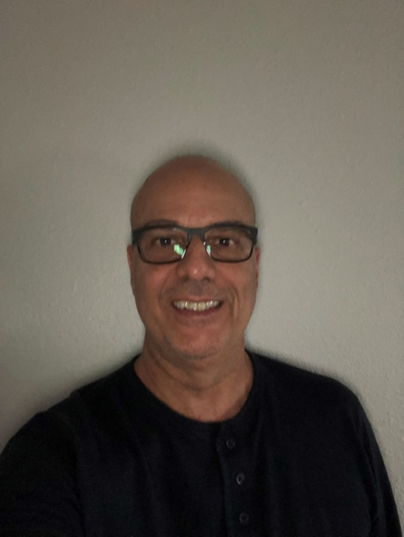
With over 10 years of experience in the field of physical therapy, Paulo Falcao has established himself as a trusted expert in post-operative rehabilitation and Sports Medicine. He has successfully treated numerous patients, helping them return to their peak performance and normal daily activities. Paulo's approach is rooted in evidence-based practices, ensuring each patient receives the best possible care. On a personal note, Paulo is an avid mountain biker, volleyball player, and paddle boarder understanding firsthand the challenges and rewards of pushing one's physical limits. He's passionate about helping his patients achieve their goals, whether it's running a marathon or simply enjoying a pain-free walk in the park.

