Arvada Candelas Team

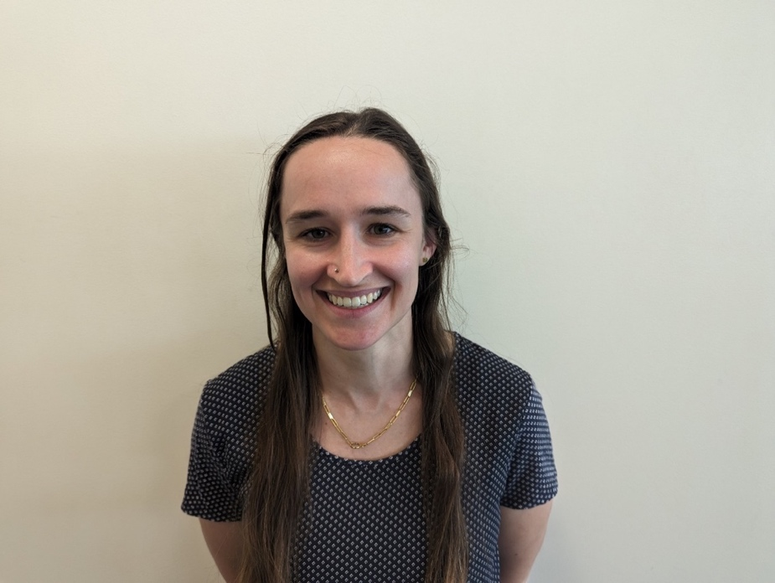
Reba Havis PT
Reba Havis grew up in Fort Collins, CO and went to Poudre High School. She enjoys Colorado’s expansive outdoors by hiking with her dogs, rock climbing, and mountain biking. She went to the University of Florida for her undergraduate education and received her Doctorate of Physical Therapy from Northeastern University in Boston, MA. Reba joined the Panorama Team in 2021 following the completion of her education. She treats various conditions of the musculoskeletal system, but takes special interest in chronic pain, hip conditions, and pelvic health.

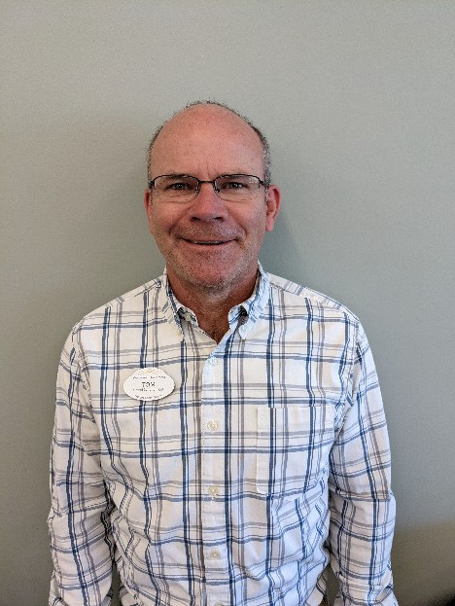
Tom Ryan, PT
A Colorado native, Tom Ryan holds a BS in physical therapy from The Robert Gordon University. Tom has an extensive background in manual therapy and has completed functional dry needling coursework. His favorite part of being a PT is interacting with people to figure out the underlying problems causing pain/dysfunction. Tom married his wife, Leslie in 2005, and is the proud father of two children. Outside the clinic, Tom enjoys spending time with family, and – like a true Coloradoan – going to the mountains, hiking, biking, and going for an occasional run.

Amy Helbok, PTA
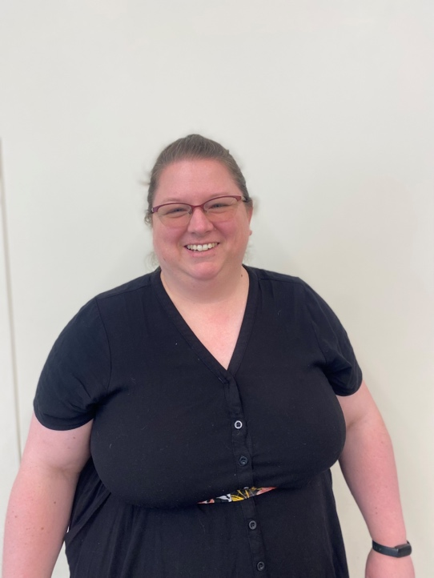
I wear many hats in my life. I am a wife, mother, PTA, instructor, and director. I have been a treating PTA for 18 years. I have an incredible son who keeps me on my toes. I love to see how he grows and the challenges he undertakes. I volunteer with Westernaires and direct plays with Colorado ACTS. I enjoy taking walks with my dogs and riding horses.

