

**Your Minimally Invasive Anterior Hip Replacement**

**with Dr Jesse Chrastil**

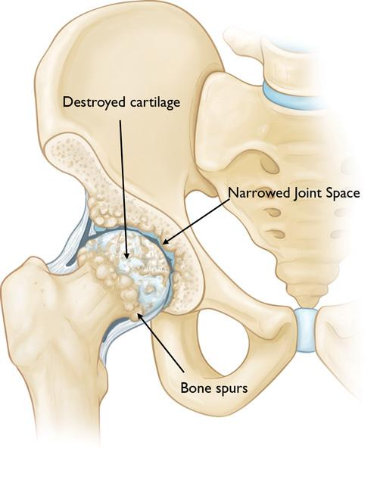

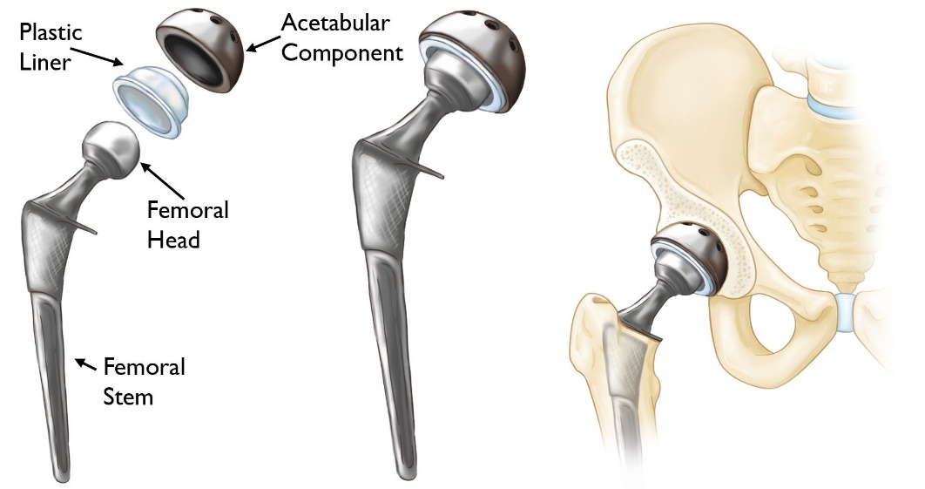

**Table of Contents:**

* ***PLEASE READ ENTIRE BOOKLET***, then use this table of contents to quickly refer back to the book for guidance during your hip replacement process.
* **Important Phone Numbers and Contacts** *[Page 3]*
* **Hip Replacement:** Brief overview *[Page 5]*
* **Scheduling Surgery:** *[Page 7]*
* **Preparation for surgery:** *[Page 8]*
* **Preoperative Exercises:** *[Page 12]*
* **Medications to Stop prior to surgery:** *[Page 15]*
* **Post-Operative Medications:** *[Page 19]*
* **Surgery & Hospital Course:** *[Page 20]*
* **Frequently Asked Questions:** *[Page 25]*
* **Post-Op Meds with Example Worksheet:** *[Page 32]*
* **Physical Therapy Locations & Contact Numbers:** *[Page 35]*
* **Chlorhexidine Gluconate (CHG) Pre-Op Instructions:** *[Page 36]*
* **Cold Therapy Unit Information:** *[Page 38]*

**Important Phone Numbers for Your**

**Surgery with Dr. Chrastil**

**Clinician Liaison:**

Kate Taylor

Clinic line – (720) 497-6191

720-497-6704 – Fax

Email – drchrastilpc@panoramaortho.com

**Surgery Scheduler:**

Kate Taylor

Clinic line – (720) 497-6191

720-497-6704 – Fax

Email – drchrastilpc@panoramaortho.com

**Physician’s Assistant:**

Tara Lang, PA-C

Clinic line – (720) 497-6191

Email – [drchrastilpc@panoramaortho.com](mailto:drchrastilpc@panoramaortho.com)

**Triage:**

Medical questions or concerns requiring immediate attention

7:00 am – 5:00 pm

Triage Line – (303) 233-1223; Option 3; Extension 1100

**Clinic Appointment Scheduling:**

(303) 233-1223; Option 2, Option 1

**Billing Office:**

(720) 497-6637

**Surgery Locations and Contact Info**

**South Denver Surgery Center:**

Main Line – (720) 360-3400

Pre-Admission Testing – (303) 589-3637

*300 E Mineral Ave #9, Littleton, CO 80122*

**Centennial Hospital:**

Main Line – (303) 699-3000

Preoperative Class – (303) 944-9500

Pre-Admission Testing – (303) 695-2764

*14200 E Arapahoe Rd, Centennial, CO 80112*

**OrthoColorado Hospital:**

Main Line – (720) 321-5450

Preoperative Class – (720) 321-5618

Pre-Admission Testing – (720) 321-5450

*11650 W 2nd Pl, Lakewood, CO 80228*

**Total Hip Replacement Surgery**

**Overview**

Dr Chrastil does an anterior muscle sparing minimally invasive hip replacement. The incision is anterior and slightly lateral on the thigh just under your pocket, it is completely muscle sparing so no muscles are cut during this procedure. The surgery takes about an hour and is usually done under a spinal anesthetic and sedation with continuous care from an anesthesiologist. We use dissolvable sutures and dermabond for closure, so no sutures or staples to remove. The postoperative dressing will in place for 2 weeks and our office removes it at the 2-week postoperative visit. You will be weight bearing as tolerated immediately after surgery. Because this surgery is an anterior hip replacement there will be no postoperative hip precautions as the risk of hip dislocation is incredibly low with this approach. Most patients use a walker for approximately 5-10 days after surgery followed by a cane for about another week. The first week to two weeks it is very common to have groin pain and thigh pain which can radiate down to the anterior or lateral knee. Swelling, bruising, and warmth around the hip are normal for 2-3 months after a hip replacement.

To find out more watch Dr Chrastil’s videos at:

https://www.panoramaortho.com/find-a-doctor/jesse-chrastil/

Or an animation from the American Academy of Orthopaedic Surgeons:

https://orthoinfo.aaos.org/en/treatment/total-hip-replacement-animation/

**An overview of what to expect:**

* The surgery itself takes 60-90 minutes.
* We usually do the surgery with a spinal anesthetic minimizing the amount of sedating medications you need during surgery (*but yes, you are still sleeping through the surgery*).
* You will wake up in the recovery room.
* You will be able to place as much weight as you would like to on the hip/leg following surgery (once the anesthesia has worn off).
* Physical Therapy is usually not required following hip replacement.
* You will follow up with Dr. Chrastil and his team at 2 weeks and ~6 weeks following surgery

**Surgery at OrthoColorado, & Centennial Hospitals:**

* Most hip and knee replacements done in the hospital setting will stay overnight and will be discharged to home the next day. We can discharge you the same day if you would like, but this is a conversation to have with Dr. Chrastil and your team.

**Surgery at Lincoln Surgery Center & South Denver Surgery Center:**

* Hip replacement in a surgery center is safe and Dr. Chrastil does them routinely. The benefit is you are able to go home the same day as surgery. If you do need to stay overnight for a medical reason, we can provide that level of care at the surgery center.

**Scheduling Surgery**

* After you have decided with Dr. Chrastil it is time to proceed with hip replacement you will be given information (including this booklet).
* Kate Taylor, Dr. Chrastil’s surgical scheduler, most likely scheduled your surgery when you met with her in clinic. If not, please contact Kate to schedule surgery and your first post-operative appointment.
* For financial guidance and what your insurance plan covers please call our Business office (see page 3 for contact information) and speak with one of our preauthorization specialists.
* ***Prior to surgery, you will NEED medical clearance from your primary care provider. Please call your PCP to schedule this appointment within 30 days of surgery. Any physical including lab work prior to the 30 days does not count, even if you had another procedure or surgery.***
* Avoid any injections of the operative hip **3 months** prior to surgery

**Preparation for Your Hip Replacement Surgery**

**6 weeks prior to surgery:**

Dr. Chrastil and his team recommend you identify a friend or family member as your “***total joint care provider***.” This person can:

* Attend education sessions with you
* Stay with you for the first 2-3 days following surgery
* Help with medications, care, transportation, etc.
* Take you home from hospital/surgical center
* Help you manage stress & anxiety following surgery

**Arrange a Surgical Clearance Visit with your primary care provider:**

* This is important, **surgery cannot proceed without prior clearance**
* Please schedule this visit to take place within 30 days prior to surgery
* If it occurs to close too surgery (less than 7 days) then any tests that may need to be ordered might not get done in time and surgery will have to be postponed
* If you do not have a primary care provider or they are unable to clear you for surgery, contact us at (720) 497-6191 or [drchrastilpc@panoramaortho.com](mailto:drchrastilpc@panoramaortho.com), and we will arrange clearances

**Pre-surgery Dental Screening:**

* You should have a dental exam within 6 months of surgery to ensure there are no major issues
* Dental issues could lead to increased risk of infection in your new hip joint
* Major dental work must be completed at least 1 month prior to surgery
* Non-urgent dental work should be postponed 3 months following surgery
* Antibiotics for dental procedures are no longer recommended after hip replacement for “routine cleanings” unless underlying health concerns (immunocompromised patient) or major dental issues are encountered (active dental infection). Please contact us with questions about this.

**Tobacco use:**

Tobacco cessation is important in the recovery following a hip replacement. Use of tobacco immediately prior to surgery or during recovery increases risks of infection and post-operative complications. Speak with Dr. Chrastil or his team with any questions about tobacco cessation.

**2 weeks prior to surgery:**

**Surgery Clearances:**

* Make sure all pre-surgical clearances have been completed. By this time, you should have had your preoperative primary care visit and all clearances addressed.

**Obtaining canes and walkers:**

* Purchase or borrow a two-wheeled walker (often used for 1-2 weeks)
* A cane is a nice transition piece from the walker (additional week)
* Optional purchases are: shower chair, toilet seat riser, hand-held shower sprayer

**1 week prior to surgery:**

* Contact Dr. Chrastil if there is any change in your medical condition prior to surgery (illness, infection, cuts/scrapes, etc.)
* Do not shave legs the week of surgery to avoid cuts or nicks
* Make sure your “total joint care provider” is still available and prepared
* If you have pets arrange for care as they may be tripping hazards and they should be kept away from your incision to minimize infection risk
* Remove small rugs or tripping hazards throughout your home
* Start the use of CHG soap/wipes (see page 36).

**48 hours prior to surgery:**

* The hospital or surgery center nurses will call you to go over health history and last-minute instructions including when to stop eating and drinking.
* The nurses will also give you the time of check-in for your surgery.

**1 day prior to surgery/Day of surgery:**

* Stay well hydrated the day before the surgery (water, juice, Gatorade)
* Do NOT eat or drink anything after midnight the evening prior to surgery. If you eat the morning of surgery, your surgery will have to be cancelled
* The night before and morning of surgery, wash with a Chlorhexidine Gluconate (CHG) wipe/solution or the solution prescribed by the facility where you are having your surgery (see attached for more information & instruction). This will help prevent infection.
* The morning of surgery, only take medications as instructed by your primary care provider or by Dr. Chrastil
* Bring your glasses, hearing aids, dentures to the hospital with you
* Bring your photo ID and insurance card to the hospital
* Wear loose fitting clothes and supportive easy to slip-on shoes
* Do not apply lotions, deodorant, perfumes
* Leave valuables and jewelry at home
* Make sure your contact information is up to date and be available the day of surgery in case the hospital or someone on Dr. Chrastil's team needs to contact you.

**Anesthesia:**

* On the day of surgery your anesthesiologist will discuss the anesthetic plans with you.
* Most patients receive a spinal anesthetic with sedation so you will be numb from the waist down until this wears off.
* You will be sleeping and unaware of the surgery but with less medication administered than a general anesthetic would require.

**Pre-Operative Exercise**

* If you are currently performing an exercise program, continue to do so.
* If you are not currently performing an exercise program, you may incorporate exercises as directed on the handouts in this booklet.

**Side-lying Hip Abduction**

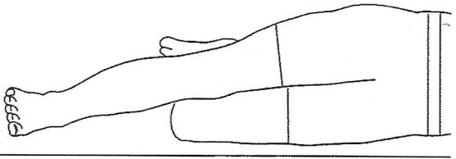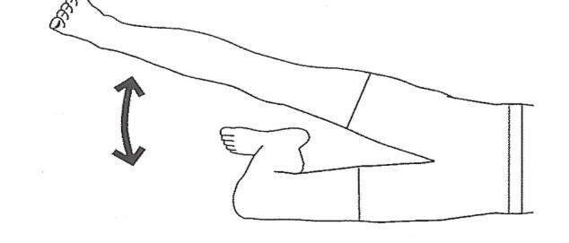

* Lie on uninvolved side, with lower knee bent for stability.
* Keep knee straight on involved leg, lifting leg upward.
* Return to start position and repeat.
* Perform 3 sets of 10 repetitions, once a day.
* Perform 1 repetition every 4 seconds.
* Rest 1 minute between sets.

**Standing Hip Extension**

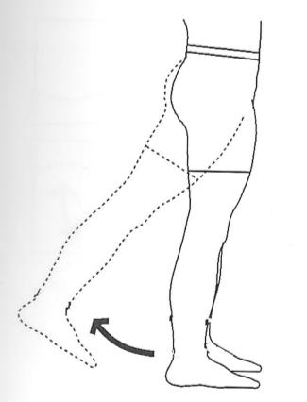Stand, hold onto table or wall for balance.

Extend leg backward, keeping knee straight.

Return to start position.

Perform 3 sets of 10 repetitions, once a day.

Perform 1 repetition every 4 seconds.

Rest 1 minute between sets.

**Straight Leg Raise**

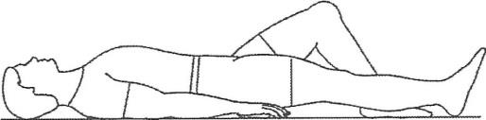

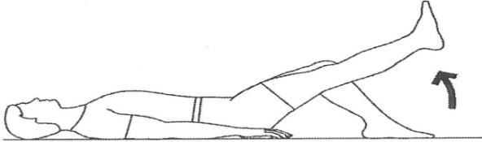

* Lie on back with uninvolved knee bent as shown.
* Raise straight leg to thigh level of bent leg.
* Return to starting position.
* Perform 1 set of 10 repetitions, once a day. Perform 1 repetition every 4 seconds.

**Sit to Stand**

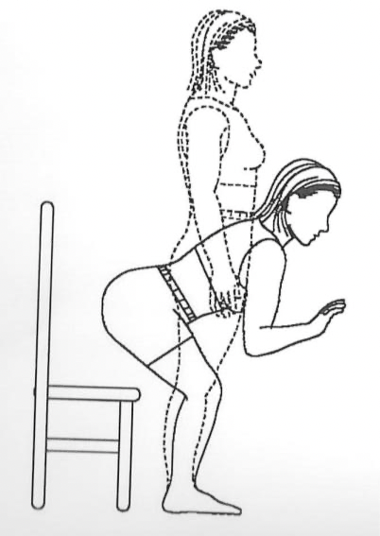

Begin standing with a chair behind you.

Lean forward slightly as you bend the knees and lower buttocks towards the chair as if attempting to sit.

Before you touch the chair, stand back up to full upright position.

Perform 3 sets of 10 repetitions, once a day.

Perform 1 repetition every 4 seconds.

Rest 1 minute between sets.

**Mini Wall Squat**

* 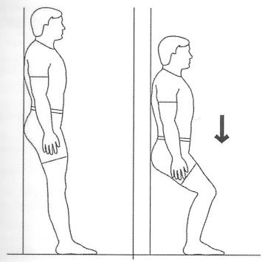Lean on wall, feet approximately 12 inches from the wall, shoulder distance apart.
* Bend knees to 45 degrees.
* Hold 5 seconds.
* Return to starting position.
* Special Instructions:
* Perform 1 repetition every 4 seconds. Perform 1 set of 10 repetitions, once a day.

**Medications before Surgery**

**Stop at Least 7 Days Prior to Surgery**

|  |  |  |  |  |
| --- | --- | --- | --- | --- |
| Stop all Aspirin* containing products such as: | | | | |
| Coated ASA | Uncoated ASA | Ecotrin | BC Powder | Disalsid |
| Salsalate | Dolobid | Diflunisal | Alka-Seltzer | Goody Powder |
| Norgesic | Pepto Bismol | Percodan |  |  |
| *If you have Heart Stents and take Plavix and Aspirin, DO NOT STOP ASPIRIN | | | | |

|  |  |  |  |  |
| --- | --- | --- | --- | --- |
| Stop all Antiplatelet* Medications such as: | | | | |
| Aggrenox (aspirin + dipyridamole) | Plavix (clopidogrel) | | Pletal (cilostazol) | |
| Trental (pentoxil) | Ticlid |  | |  |
| *If You Have Heart Stents: DO NOT STOP PLAVIX DIRECTED BY A CARDIOLOGIST PRIOR TO SURGERY | | | | |

|  |
| --- |
| Anticoagulation Medications such as Coumadin need a plan with your provider care provider (i.e. need for Lovenox bridging etc.) |

|  |  |  |  |  |
| --- | --- | --- | --- | --- |
| Stop birth control pills & any male or female hormone (including creams or patches) such as: | | | | |
| Estrogens | Estradiol | Estraderm | Premarin | Prempro |
| Estrace | Estratest | Ogen | Emcyt | Testosterone |

|  |  |  |  |  |
| --- | --- | --- | --- | --- |
| All herbal & weight loss medications such as: | | | | |
| Alpha lipoic acid | Cinnamon | Chamomile | Creatine | Echinacea |
| Acetyl L-carnitine | Ephedra | Fish oil | Garlic | Ginkgo |
| Milk Thistle | Glutamine | Goldenseal | Licorice | Kava |
| L- carnosine | Ginseng | Skullcap | Saw Palmetto | St. John’s Wort |

|  |  |  |  |  |
| --- | --- | --- | --- | --- |
| Stop all vitamins and joint supplements containing products such as: | | | | |
| Vitamin A | Vitamin C | Vitamin E | Vitamin K | Fish Oil |
| Omega 3,6,9 | CoQ10 | Juice Plus | Krill Oil | Glucosamine |
| Chondroitin | MSM |  |  |  |

|  |  |  |  |  |
| --- | --- | --- | --- | --- |
| Stop all non-steroidal anti-inflammatory (NSAID) medications such as: | | | | |
| Ibuprofen | Advil | Nuprin | Ketoprofen | Oruvail |
| Orudis | Relafen | Nabumetone | Arthrotec | Voltaren |
| Tolectin | Tolmetin | Cataflam | Clinoril | Sulindac |
| Oxaprozin | Daypro | Diclofenac | Etolodac | Mobic |
| Meloxicam | Naproxen | Naprosyn | Indocin | Indomethacin |
| Celebrex | Celecoxib | Aleve | Anaprox | Ansaid |
| Feldene | Piroxicam | Naprelan | Lodine | Meclomen |
| Meclofenamate | Mediprin |  |  |  |

|  |  |  |  |  |
| --- | --- | --- | --- | --- |
| Contact your primary care provider for instructions if you take any of the following medications: | | | | |
| Humira | Remicade | Imuran | Enbrel | Rituxan |
| Actemra | Kineret | Cosentyx | Stelara | Benlysta |
| Xeljanz | Cimzia | Orencia | Librium | Librax |
| Cytoxan | Adderall |  |  |  |
| *Your prescribing physician should help with monitoring these medications* | | | | |

***If you do not see a medication on these lists that you are taking, please contact your primary care physician to ask when to stop taking it.***

You may continue taking the following medications:

* Cholesterol medications
* Psychiatric medications
* Gabapentin
* Tylenol (regular, extra strength, arthritis)
* Ultram (Tramadol)
* Thyroid medications
* Ultracet
* Iron supplements
* Blood pressure medications – see additional instruction below regarding your blood pressure medication:

You should **NOT** take the following blood pressure medications on the day of surgery:

* ACE Inhibitors. Common ACE Inhibitors include:
  + benazepril (Lotensin), captopril (Capoten), enalapril (Vasotec), lisinopril (Prinivil, Zestril), quinapril (Accupril)

* Angiotensin Receptor Blockers (ARBs). Common ARBs include:
  + losartan (Cozaar), olmesartan (Benicar), telmisartan (Micardis), valsartan (Diovan)

* Diuretics. Common diuretics include:
  + hydrochlorothiazide (HCTZ, Microzide), furosemide (Lasix) spironolactone (Aldactone), triamterene (Dyrenium), chlorthalidone, bumetanide
* Pills that contain combinations of ACE Inhibitors, ARBs or diuretics

It is **OK** to take the following blood pressure medications on the day of surgery:

* Beta blockers. Common beta blockers include:
  + atenolol (Tenormin), metoprolol (Lopressor, Toprol), carvedilol (Coreg), propranolol (Inderal), acebutolol, bisoprolol, nadolol, penbutolol, pindolol
* Calcium channel blockers. Common calcium channel blockers include:
  + amlodipine (Norvasc), diltiazem (Cardizem, Tiazac), nifedipine (Procardia), verapamil (Calan, Verelan, Covera-HS, nicardipine (Cardene SR), felodipine
* Vasodilators. Common vasodilators include:
  + hydralazine, minoxidil, clonidine (Catapress), doxazosin (Cardura)

**Preventing and Treating Opioid-Induced Constipation:**

2 DAYS BEFORE SURGERY:

* For constipation start Senna-S (Senna + Docusate)

(can substitute with Senna and Docusate as separate medications)

* Take 2 tablets, twice a day starting 2 days before surgery - if you experience loose or watery stools, STOP using the Senna-S and resume it the night of surgery
* Drink at least eight 8 ounce cups of water daily
* Be active
* Eat foods high in fiber

**Post-Operative Medications:**

|  |
| --- |
| Blood thinning medication to prevent blood clots  *Either Aspirin or Eliquis will be used as a blood thinner based on your medical history. In certain cases, other blood thinners (Lovenox or Coumadin) will be substituted.* |
| **Aspirin:** 81mg tablet to be taken twice a day for 30 days after surgery, to help prevent blood clots. *(Ok to stop after 30 days)* |
| **Protonix (Pantoprazole**): Stomach protector: Take 1 tablet daily, in the morning to protect your stomach. You should continue to take this medication for 30 days while you take aspirin. |
| **Eliquis (Apixaban):** 2.5mg tablet to be taken twice a day for 10 days total after surgery to help prevent blood clots |

|  |
| --- |
| Narcotic pain medications “as needed” for pain control |
| **Oxycodone (Percocet):** Short-acting pain pill to be used as needed for breakthrough pain. You may take 1-2 tablets every 4 hours. |
| **Hydrocodone/Acetaminophen (Norco or Vicodin):** Short-acting pain pill to be used as needed for breakthrough pain. You may take 1-2 tablets every 4-6 hours. The daily limit is 12 pills /24 hours. |
| **Hydromorphone (Dilaudid):** Short-acting pain pill to be used as needed for breakthrough pain. You may take 1-2 tablets every 4 hours. |
| **Tramadol:** Short-acting pain pill to be used as need. You make take 1-2 tablets every 4-6 hours. *(****May Combine with Above Narcotic Pain Medications****)* |

|  |
| --- |
| Prescription non-steroidal anti-inflammatories |
| **Meloxicam (Mobic):** Anti-inflammatory, take 15 mg once a day for a total of 6 weeks after surgery. Make sure you take this medication with food. |
| **Celecoxib (Celebrex):** Anti-inflammatory, take twice a day for a total of 6 weeks after surgery. Make sure you take this medication with food. |

|  |
| --- |
| Constipation prevention |
| Senokot-S (SennaPlus): Stool softener/laxative for constipation. Take 2 tablets twice a day starting 2 days before surgery until you are off all narcotics after surgery. |
| Other over the counter alternatives: Miralax, Exlax, Milk of Magnesia |

**Surgery and Hospital Course**

**The Day of Surgery**

* With this anterior minimally invasive hip replacement and contemporary pain control methods, most of Dr. Chrastil’s patients will go home the same day or the day after surgery.

**Preoperative Unit:**

* You will arrive at the front desk of the hospital 2-3 hours prior to your surgery.
* You will be taken to the preoperative area where you meet with nurses, anesthesiologists, and Dr. Chrastil.
* An IV will be placed in preparation for your procedure.
* Any remaining questions or concerns that you have will be addressed.
* You will be taken to the operating room for your surgery.
* Surgery takes approximately 1 hour.

**Recovery Unit:**

* After surgery, you will spend approximately one hour in the recovery room, where nurses will monitor you as you recover from anesthesia.
* If you are to be admitted to the hospital, after approximately one hour in the recovery unit the nurses will contact your family/friends to let them know the room number.
* IF you are planning on discharging the same day you will be in the recovery unit longer.
  + You will be required to get up and move, use the restroom, and will be determined to be safe to discharge to home by therapy and nurses in the recovery unit.
  + You can spend most of the day in the recovery area so please coordinate with your “***total joint care provider***” so they can plan appropriately.

**Hospital Unit (“The floor”):**

* If you plan on staying the night at the hospital you will be admitted to a private room on the floor, where the nursing staff will care for you.
* Your pain will be monitored and controlled.
* It is impossible to be completely pain free after a hip replacement surgery.
* On the day of surgery, you will walk with a walker, which is Dr. Chrastil’s preferred assistive device. It is stable and reduces risk of falls in the post-operative period. Unless otherwise instructed, you will be allowed to put full weight on the operated leg.
* Early walking is good for your new hip replacement. Walking is the most important thing you can do to prevent blood clots. Moving your leg is more important than medications we give to prevent clotting.

**The day after surgery (post-operative day #1), if you stay in the hospital:**

* Labs will be drawn in the morning.
* The physical and occupational therapists will continue to work with you on walking, stairs, bathing, getting dressed, and other activities required for daily living.
* Most patients who stay in the hospital will be discharged to go home on postoperative day #1.

**Post-operative day #2:**

* If you are still in the hospital on postoperative day 2, you will work with physical and occupational therapists to help you regain independence. You will go home after you fulfill the goals of therapy.
* If it is determined that you require extra assistance, or that going home will not be ideal for your recovery, then our case managers will arrange for you to be transferred to a skilled nursing facility or rehabilitation until you are ready to go home.
* Please note that Dr. Chrastil does *not* make the determination on whether a rehab facility is the ideal placement. This decision is made in the hospital by the recovery team and case management arranges with insurance.

**What to Expect After Surgery:**

* EXPECT to have some pain after surgery. hip replacement surgery is a major operation, and operations hurt.
* The first 2 weeks after surgery you should expect to have pain and require narcotic level pain medication regimens.
* After the first 1-2 weeks, the pain will start improving and you will notice there does seem like there is “light at the end of the tunnel”.
* It takes about 4-6 weeks until your pain level and functionality is to the level as you were prior to surgery.
* Dr. Chrastil’s goal is to keep you comfortable, but being “pain free” is not realistic immediately after any hip replacement.
* A reasonable goal is to keep your pain at 3 or 4 out of 10 or less while you are at rest. This is accomplished by providing you with the appropriate pain medications. You may have pain that is greater than 3 or 4 out of 10 while you are walking and moving your hip in the first several weeks. This is a normal part of the healing process.
* It is important that you stay “ahead of your pain,” meaning you should adjust your pain medications when you are feeling greater than 3 or 4 out of 10 pain while at rest.
* It is important to monitor your progress and wean off your pain medication as your get further out from surgery.
* Hip/groin and thigh pain are particularly common after surgery.
* You will have bruising and swelling initially that will start at the surgical site.
* Bruising and swelling are normal after surgery and vary from person to person. This can be quite severe and it should not worry you as it is completely normal.
* Bruising and swelling will continue to increase over the first 1-2 weeks after surgery, especially after you have been up and standing/walking for prolonged periods.
* Bruising may travel to your buttock and may move down to your knee or even toes within the first 2 weeks.
* In the first week or two, expect significant swelling in your entire leg and foot. Wearing the compression stockings (TED hose) as instructed during the first 2 weeks after surgery will decrease your swelling. These will be provided in the hospital.
* Elevating the operative leg also helps decrease swelling. The swelling will eventually resolve with time.
* Sleeping may be difficult in the first several weeks to months. This is due to the physiologic burden of surgery, the new medications you are on, and a change in your activity level. This is common and not abnormal.
* Napping during the day may make sleeping at night difficult.
* It is also important that your pain is well controlled at night.
* Fatigue is common following surgery. This is due to sleep disturbance (see above), medication effects, changes in your daily activity level, and the physiologic burden of surgery on the body.
* *Eventually* you will get your energy back, but this may take several weeks or even several months for some people.
* Occasionally Physical Therapy is necessary and you should have an open dialogue about your personal therapy needs with Dr Chrastil at your follow-up visits.
* A list of recommended physical therapy clinics has been provided in this booklet for your convenience.

**Post-Operative Follow Up**

* We will ask you to return to the office at routine times after your discharge from the hospital.
* You will be seen in our office approximately two weeks from the time of surgery for your first post- operative visit.
* Please bring ALL of the post-operative medications that you are currently taking (either written down or in a bag) so Dr. Chrastil or someone from Dr. Chrastil’s team can review and adjust them as needed.
* The two-week appointment includes an incision check, standard physical examination and medication check/refill.
* We will ask you to return to the office again approximately six weeks from your surgery.
* The six-week appointment includes a physical examination, medication check, and at this visit there will be x-rays.
* ***Telemedicine visits for the postoperative follow-ups are available if you prefer***.
* Further follow-up visits will occur at 4-6 months, 1 year, 3 years, 5 years, and every 5 years thereafter, or as determined by your surgeon.
* It is important to come in for routine evaluations and X-Rays, even if you are feeling great, to monitor the implant for any signs of loosening, wear, or early failure that should be addressed.
* Should you desire to schedule a visit for any reason whatsoever, you are always welcome to do so.

**Frequently Asked Questions:**

**1. I need a refill of my medication. Who do I call?**

* If you need a refill of your medication at any point, you need to call Panorama’s Prescription line. Call the ***main office line*** (303-233-1223) and follow the prompts for PATIENT/CARE TEAM/MEDICATION REFILLS. This ensures speedy answers as this line is answered the same business day as long as you call before 3PM. If you call our clinician liaison’s direct line (see page 3), you will get an answer, but we cannot guarantee same day service as we are often in clinic.

**2. I went home with oxygen; how long do I need it and how do I get rid of it?**

* Occasionally, patients are sent home from the hospital with oxygen to help improve breathing for a few days or weeks. The decision to put you on oxygen is made by the internal medicine doctors and respiratory therapists at the hospital. To stop home oxygen and to have your oxygen tank picked up by the company, contact the number given to you at the time of your hospitalization to arrange the time and place to pick up the oxygen tank.

**3. What is the healing process like after a hip replacement?**

* Expect to go home the same day of surgery (if prearranged) OR be in the hospital for one night. On the day of surgery you should expect to put full weight on, as well as walk on the leg with your new hip! Initially, you may use a cane or walker to help you walk. You can eliminate these walking aids whenever you feel comfortable doing so. When you first begin to ambulate on your new hip, you may have pain. Pain generally improves dramatically in the first several days and weeks after surgery. The first 2 weeks are generally the most difficult. Groin and thigh soreness is especially common in the first few weeks. On average, by week 6 most patients are about 75-80% recovered (“healed”) from surgery. By 3 months most patients are about 90% recovered. Complete recovery, including maximal pain relief and function, takes about 6 months to a year. Patients generally begin driving and returning to work between 1 and 6 weeks after surgery.

**4. What will my hip feel like when I am completely healed?**

Having a realistic expectation about your hip replacement will ultimately lead to your satisfaction with the surgery. The goal of hip replacement is to improve your pain and your function. Most people can expect to have a hip that feels natural and pain free when it is completely healed. You may have a small area of numbness around the incision. Some people with hip replacements may have periodic tenderness around the lateral or outermost point of the hip (“trochanteric bursitis”).

**5. How long will my hip last?**

* This is a difficult question to answer as many factors determine the longevity of a hip replacement. With the new advances in the materials we are now hoping for 25-30 plus years.

**6. Is swelling common after hip replacement?**

* Yes. In fact, you should anticipate quite a bit of swelling from your thigh to your foot after surgery. Your operative leg may swell to as much as 30% larger than your other leg. The swelling peaks at about 7-10 days after surgery and gradually diminishes. Sometimes the leg can have substantial bruising as well. This bruising is not dangerous. Elevating your leg and wearing a support stocking help decrease the swelling. It may take months for all the swelling to resolve.

**7. Why do I have to take all these medications after my surgery?**

* Medications after surgery are prescribed to help ensure a safe and comfortable recovery. Blood thinners are necessary to help avoid developing blood clots. Pain medications help decrease your discomfort after surgery. Dr. Chrastil uses “multi-modal” pain control, which has been clinically proven to be effective after total hip replacement. Multi-modal pain control uses different types of medication, which can decrease the need for opioids. In general, patients are given an anti-inflammatory medication (Meloxicam/Celebrex) for 6 weeks, a short acting “as needed” opioid medication (oxycodone, hydrocodone, or hydromorphone), and a moderate, as needed, pain medication (Tramadol). The most common side effects from these opioid medications are nausea, constipation, and itching. As such, you may be given an anti-nausea medication (Zofran or a Scopolamine patch), stool softeners (Senokot, Docusate, Senna-S), and anti-itching medication if needed (Benadryl, Atarax). If your insurance does not pay for a particular medication or if you do not wish to take a particular one you do not need to take it. Most of these are on an “as-needed” basis.

**8. Is it normal to have numbness around the incision after surgery?**

* Yes. Hip replacement requires an incision to be made in the front of your hip and one of the retractors places pressure on a superficial nerve. Most of the time this numbness around the incision returns. In up to 5% of people there will always be a numbness on the outside of the incision but this is not dangerous and this is a “sensory only” nerve so there will be no weakness associated with the numbness. Eventually the numbness becomes less and less noticeable.

**9. What should my activity level be after surgery?**

* Every patient is different. Each day you should be increasing your activity level, but let pain and swelling be your guide. The first 2 weeks are associated with the most pain. On average, you will make 75-80% of your recovery by week 6 and 90% by 3 months. At some point, most patients overdo it with activities and therefore take a few steps back in their recovery temporarily. You may have increased swelling or discomfort if this happens. This is your body telling you to take it easy and let your new hip rest for a few days.

**10. When can I shower or bathe?**

* You can shower the day after surgery, and let water run over your hip and leg. Your dressing is waterproof. Leave it in place. We will remove the dressing at the two-week visit. You should avoid soaking in a bath or pool for at least 5-6 weeks after surgery, when your incision is completely healed.

**11. I just had a hip replacement. What positions can I sleep in?**

* You may sleep in any position you are comfortable in. It is going to be sore if you sleep directly on the incision but however you are comfortable and can get sleep should be ok. Some people feel more comfortable with a pillow between their knees for a few weeks following surgery.

**12. I am having difficulty sleeping after my hip replacement. Is this normal? What can I do about it?**

* Patients often experience difficulty falling or staying asleep in the first few weeks to even months after hip replacement. Some even describe restless leg-like symptoms. Sleep may be disrupted for many reasons. This is likely related to changes in your daily routine, medications you are taking, and changes to your body’s metabolism during the healing process. Your sleeping patterns will eventually normalize. To improve sleep at night, remain active during the day and avoid excessive napping. Sleep medications are sometimes useful short term and you could start with over the counter sleep aides such as Tylenol PM, Advil PM, Melatonin, Valerian root, etc.

**13. Why am I so tired all the time?**

* It is normal to experience fatigue after hip replacement. This is due to a combination of the effects of pain medication, disrupted sleep patterns, and the physiologic toll that the surgery takes on your body while you are healing. You **will** regain your energy and stamina. In some cases, it may take up to 3 months to get past the fatigue.

**14. When can I restart the medications I was told to stop prior to surgery?**

* Usually, as soon as you are discharged from the hospital, but check with Dr. Chrastil or your primary care provider if there are any medications in question. You will be informed which medications you should resume when you leave the hospital.

**15. What should I do to avoid or alleviate constipation?**

* You should start taking your stool softener (Senna-S) two days before surgery and continue it twice daily until you have a normal bowel movement or while taking narcotic pain medication. Stop the stool softener if you start to experience loose or watery stools. If you continue to have constipation you can take Milk of Magnesia, which is a mild oral laxative, or use Magnesium Citrate, which is much stronger. In addition, you can also try Dulcolax suppositories or a Fleets enema. All of these medications can be bought over the counter at your pharmacy.

**16. What are the major risks of hip replacement surgery?**

* **Infection**: Infection is the biggest risk after hip replacement and can occur anywhere from days to years after surgery. An infected total hip replacement requires surgery (sometimes multiple surgeries), and great measures are taken to help avoid infection. The national infection rate after hip replacement is about 1 in 100-200 replacements (~0.5%).
* **Blood clots**: A blood clot, also known as deep vein thrombosis (DVT), may occur after surgery and can be potentially life threatening if it travels to your lungs. The risk of death from blood clots has been greatly reduced in recent years by the use of anticoagulants (blood thinners) and early mobilization (walking, moving, etc.). The symptoms of DVT are new or extreme swelling or a sudden increase in pain in the leg or calf. (Note that substantial swelling is normal and expected, as is some moderate calf and thigh pain. Most instances of swelling and pain are ***normal****.*)
* If you or your physical therapists are concerned with the amount of swelling in your leg, call my clinician liaison (see page 3).
* Chest pain or shortness of breath are possible signs of a DVT that has moved to the lungs (called a pulmonary embolus or “PE”). If you experience chest pain or shortnessof breath, go to the ER immediately.
* **Continued pain after hip replacement**: In rare cases people will continue to have pain after a total hip replacement. Often the cause of this pain can be determined, but rarely it may be difficult to tell why a hip still hurts. Fortunately, this is uncommon. Residual pain in the groin is most frequently caused by hip flexor irritation and tendonitis and can be treated with therapy.
* **Need for more operations**: Most hip replacements last many years. Early reoperation may be required in rare cases.
* **Nerve or blood vessel injury**: Major nerve or blood vessel injury is exceedingly uncommon after hip replacement surgery.
* **Dislocation:** Dislocation occurs when the ball comes out of the socket. This occurs very rarely with an anterior hip replacement. Dislocation requires reduction of the dislocation (usually in the emergency room). Dislocations that recur may require additional surgery.
* **Limb Length Inequality:** This occurs very rarely with an anterior hip replacement as we use imaging guidance in the surgery to verify leg lengths. Occasionally, the operative leg will feel longer or shorter than the other leg but this sensation should improve with time after the surgery. Frequently this is just a perceived inequality from the muscles recovering from surgery.

**Post-Operative Medication Guide:**

|  |
| --- |
| **Blood thinning medication to prevent blood clots**  *Either Aspirin or Eliquis will be used as a blood thinner based on your medical history. In certain cases, other blood thinners (Lovenox or Coumadin) will be substituted.* |
| **Aspirin:** 81mg tablet to be taken twice a day for 30 days after surgery, to help prevent blood clots. *(Ok to stop after 30 days)* |
| **Protonix (Pantoprazole**): Stomach protector: Take 1 tablet daily, in the morning to protect your stomach. You should continue to take this medication for 30 days while you take aspirin. |
| **Eliquis (Apixaban):** 2.5mg tablet to be taken twice a day for 10 days total after surgery to help prevent blood clots |

|  |
| --- |
| **Narcotic pain medications “as needed” for pain control** |
| **Oxycodone (Percocet):** Short-acting pain pill to be used as needed for breakthrough pain. You may take 1-2 tablets every 4 hours. |
| **Hydrocodone/Acetaminophen (Norco or Vicodin):** Short-acting pain pill to be used as needed for breakthrough pain. You may take 1-2 tablets every 4-6 hours. The daily limit is 12 pills /24 hours. |
| **Hydromorphone (Dilaudid):** Short-acting pain pill to be used as needed for breakthrough pain. You may take 1-2 tablets every 4 hours. |
| **Tramadol:** Short-acting pain pill to be used as need. You make take 1-2 tablets every 4-6 hours. *(****May Combine with Above Narcotic Pain Medications****)* |

|  |
| --- |
| **Prescription non-steroidal anti-inflammatories** |
| **Meloxicam (Mobic):** Anti-inflammatory, take 15 mg once a day for a total of 6 weeks after surgery. Make sure you take this medication with food. |
| **Celecoxib (Celebrex):** Anti-inflammatory, take twice a day for a total of 6 weeks after surgery. Make sure you take this medication with food. |

|  |
| --- |
| **Constipation prevention** |
| Senokot-S (SennaPlus): Stool softener/laxative for constipation. Take 2 tablets twice a day starting 2 days before surgery until you are off all narcotics after surgery. |
| Other over the counter alternatives: Miralax, Exlax, Milk of Magnesia |

**These are the most common medications prescribed postoperatively. You can use the following chart to document your medication usage. If you like the chart and would like to print off more please go to my website** [**https://www.panoramaortho.com/find-a-doctor/jesse-chrastil/**](https://www.panoramaortho.com/find-a-doctor/jesse-chrastil/)

**Follow the link to Extra Medication charts to print more and keep track of your medications.**

|  |  |  |  |  |  |  |
| --- | --- | --- | --- | --- | --- | --- |
| **Daily Medication Schedule [AM]**  **Today’s Date: ______/_______/___________** | | | | | | |
| Medication Taken: | Time medication taken (use military time) | | | | | |
|  | 0200 | 0400 | 0600 | 0800 | 1000 | 1200 |
| Blood Thinner |  |  |  |  |  |  |
| Anti-inflammatory |  |  |  |  |  |  |
| Protonix |  |  |  |  |  |  |
| Constipation Med |  |  |  |  |  |  |
|  |  |  |  |  |  |  |
| Narcotic Med |  |  |  |  |  |  |
|  |  |  |  |  |  |  |
| Tramadol |  |  |  |  |  |  |
|  |  |  |  |  |  |  |

|  |  |  |  |  |  |  |
| --- | --- | --- | --- | --- | --- | --- |
| **Daily Medication Schedule [PM]**  **Today’s Date: ______/_______/___________** | | | | | | |
| Medication Taken: | Time medication taken (use military time) | | | | | |
|  | 1400  (2pm) | 1600  (4pm) | 1800  (6pm) | 2000  (8pm) | 2200  (10pm) | 2400  (MN) |
| Blood Thinner |  |  |  |  |  |  |
| Anti-inflammatory |  |  |  |  |  |  |
| Protonix |  |  |  |  |  |  |
| Constipation Med |  |  |  |  |  |  |
|  |  |  |  |  |  |  |
| Narcotic Med |  |  |  |  |  |  |
|  |  |  |  |  |  |  |
| Tramadol |  |  |  |  |  |  |
|  |  |  |  |  |  |  |

Please take notes here: ___________________________ ____________________________________________________________________________________________

**Example Medication Schedules**

**This form is to be used as an example ONLY**

|  |  |  |  |  |  |  |
| --- | --- | --- | --- | --- | --- | --- |
| **Daily Medication Schedule [AM]**  **Today’s Date: ______/_______/___________** | | | | | | |
| Medication Taken: | Time medication taken (use military time) | | | | | |
|  | 0200 | 0400 | 0600 | 0800 | 1000 | 1200 |
| Blood Thinner |  |  |  | ASA81 |  |  |
| Anti-inflammatory |  |  |  | Mobic |  |  |
| Protonix |  |  |  | X |  |  |
| Constipation Med |  |  | X |  |  |  |
|  |  |  |  |  |  |  |
| Narcotic Med |  | 1 tab |  | 2 tabs |  | 1 tab |
| (using Oxycodone) |  |  |  |  |  |  |
| Tramadol |  |  | 1 tab |  |  |  |
|  |  |  |  |  |  |  |

|  |  |  |  |  |  |  |
| --- | --- | --- | --- | --- | --- | --- |
| **Daily Medication Schedule [PM]**  **Today’s Date: ______/_______/___________** | | | | | | |
| Medication Taken: | Time medication taken (use military time) | | | | | |
|  | 1400 | 1600 | 1800 | 2000 | 2200 | 2400 |
| Blood Thinner |  |  |  | ASA81 |  |  |
| Anti-inflammatory |  |  |  |  |  |  |
| Protonix |  |  |  |  |  |  |
| Constipation Med |  |  | X |  |  |  |
|  |  |  |  |  |  |  |
| Narcotic Med |  | 1 tab |  |  | 2 tabs |  |
|  |  |  |  |  |  |  |
| Tramadol |  |  | 1 tab |  |  | 1 tab |
|  |  |  |  |  |  |  |

**Physical Therapy**

|  |  |  |
| --- | --- | --- |
| Panorama Physical Therapy – Highlands Ranch | 1060 Plaza Dr STE 110, Highlands Ranch, CO 80129 | 720-497-6173 |
| Panorama Physical Therapy – Highlands Ranch Town Center | 1265 Sergeant Jon Stiles Drive  Suite D  Highlands Ranch CO 80129 | 303-274-7332 |
| Panorama Physical Therapy – Littleton | 5005 S Kipling Parkway, Unit A-4, Littleton CO 80127 | 303-274-7331 |
| Panorama Physical Therapy – Lakewood | 437 S Wadsworth Blvd, Unit G  Lakewood CO 80226 | 303-274-7310 |
| Panorama Physical Therapy – Golden | 660 Golden Ridge Road, Suite 130, Golden, CO 80401 | 720-497-6616 |
| Panorama Physical Therapy – Westminster | 8510 N Bryant St, Suite 130  Westminster CO 80031 | 720-497-6666 |
| Panorama Physical Therapy – Westminster at Bradburn | 4550 Main Street  Suite #200  Westminster CO 80031 | 720-497-6162 |
| Rocky Mountain Spine & Sport PT – Lone Tree | 9218 Kimmer Dr,  Lone Tree, CO 80124 | 303-792-7377 |
| Rocky Mountain Spine & Sport PT – Castle Rock | 4284 Trail Boss Dr,  Castle Rock, CO 80104 | 303-663-8086 |
| Rocky Mountain Spine & Sport PT – Littleton | 10268 W Centennial Rd, Littleton, CO 80127 | 303-948-2999 |
| Rocky Mountain Spine & Sport PT – Parker | 19964 Hilltop Rd, Parker, CO 80134 | 303-840-4667 |
| Rocky Mountain Spine & Sport PT – Centennial | 6202 S Parker Rd Unit 500, Centennial, CO 80016 | 720-361-2304 |
| Rocky Mountain Spine & Sport PT – South Lakewood | 3255 S Wadsworth Blvd STE A-2, Lakewood, CO 80227 | 303-993-4438 |
| Rocky Mountain Spine & Sport PT – DTC | 5139 S Yosemite St,  Greenwood Village, CO 80111 | 303-284-3523 |
| Rocky Mountain Spine & Sport PT – Evergreen | 1262 Bergen Pkwy,  Evergreen, CO 80439 | 303-674-7889 |
| Rocky Mountain Spine & Sport PT – Arvada | 15530 W 64th Ave,  Arvada, CO 80007 | 303-424-4589 |

**Chlorhexidine Gluconate (CHG)**

Skin bacteria are the most common cause of post-operative surgical wound infections. These wipes will clean your skin before surgery and help prevent infection at the surgical site. The wipes contain an anti-septic called Chlorhexidine Gluconate (CHG). CHG kills bacteria on skin that could cause a wound infection.

**Directions:**

* You will need to pick up over-the-counter wipes or soap at any pharmacy and you will use this once a day, every day for 5 days before surgery.
* Do not shave any areas of the body at least 5 days prior to surgery except the face, if desired.
* Avoid contact with eyes, ears, mouth, genital and rectal areas, and colostomy if you have one.
* Closed packages containing wipes may be warmed by soaking in warm water. Do not microwave wipes.
* Use wipes on cool and dry skin or soap as directed on the bottle.
* Dress in freshly laundered nightwear. Sleep on freshly laundered sheets.
* Throw wipes in garbage. DO NOT flush in the toilet.

Preparing the skin the *evening before surgery*:

* Shower or bathe and shampoo your hair as usual the evening before surgery. Use CHG soap in the shower or wait one hour after your shower before using the wipes.
* If using wipes, use one cloth to wipe each area of the body for 20 seconds in the following order:
  + Start with your operative hip and anterior thigh.
  + Wipe your neck, chest and abdomen – *not the face*.
  + Wipe both arms, front and back, starting with the shoulder and ending at the fingertips. Be sure to thoroughly wipe the arm pit areas.
  + Wipe your groin. Be sure to wipe folds in the groin area.
  + Wipe the remainder of both legs, starting at the mid-thigh and ending at the toes.
  + Wipe your outer buttocks – not the rectal area.
  + Once you use the wipes do not shower, bathe or apply lotions, moisturizers, or makeup.
  + Do not rinse your skin.

The *morning of surgery*:

* DO NOT shower, bathe, or shampoo in the morning.
* Repeat the same skin cleansing process as outlined above.
* Wear freshly laundered, clean clothes to the hospital.

**CHG Pre-Operative Skin Preparation: Frequently Asked Questions**

Q: Why does my skin feel itchy or tacky after using the CHG wipes? Is that a reaction?

A: You may experience a very mild itching sensation as the CHG dries on the skin. Avoid rubbing the skin too vigorously to minimize the itching. There will be a tacky feeling for a little while afterwards as well. This is normal. However, if a rash or skin irritation develops, do not do the second skin cleansing and notify the staff in the pre-operative area the day of surgery.

Q: Why does the skin need to cool off before applying the CHG?

A: It is ok to apply the CHG if your skin temperature is normal or cooler. When the skin is warm the pores are open and you are more likely to develop a skin irritation.

Q: What if I already have a rash, burn, cut, open wound or other irritation of the

skin? Should I still use it?

A: No do not use it if the skin is not intact.

Q: Why do we need to apply it so many times and over most of the body?

A: The protocol we are using to prepare your skin takes advantage of a “stacked effect” of repeated usage. Each preparation lasts for at least 6 hours before bacteria start to grow back. Each subsequent preparation decreases your whole body’s skin bacterial levels prior to surgery, which then decreases your chances of developing a post- operative infection.

**Cold Therapy Unit**

* Cold Therapy Units are available to use after your hip replacement. They are less critical to obtain for a hip as they are for knee replacement surgeries, but they are an option and some patients find them to be very beneficial.
* Panorama Orthopedics and Spine has contracted pricing with DonJoy and can assist in obtaining a therapy unit. These units are not covered by insurance, but have been found to improve post-operative pain and swelling with the ultimate goal to speed patient recovery and rehabilitation. Pricing can be discussed with our medical supply shops or vendors.

