**Golden Physical Therapy Team**

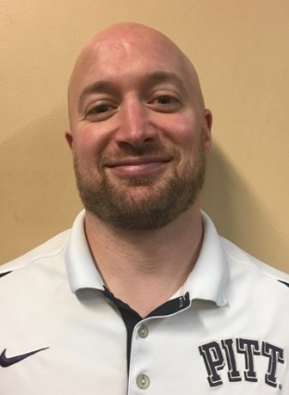

**Adam Bahnson, PT, DPT, ATC** - Adam graduated from nationally top ranked University of Pittsburgh with a BS and an Athletic Training Certification (ATC) in 2004 and a Doctor of Physical Therapy (DPT) in 2007 both with honors. Adam has also continued to progress in his professional education and development receiving a level two Dry Needling Certification in 2011. Adam specializes in a wide variety of orthopedic pathology and utilizes manual and evidence based practice treatment approaches to maximizing outcomes and recovery.

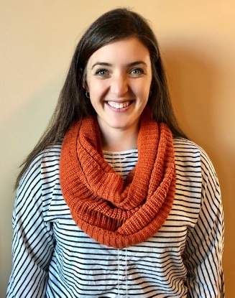

**Lara Baum, PT, DPT, OCS** - Lara graduated from University of Colorado in 2015 with her Doctorate of Physical Therapy, and has been a member of Panorama’s team since spring of 2018 and is a Board Certified Orthopedic Specialist. Lara enjoys working with all orthopedic conditions, but specializes in lower extremity injuries in athletes. She is certified in Functional Dry Needling and utilizes the Selective Functional Movement Assessment to identify biomechanical and neuromuscular dysfunctions in her patients.

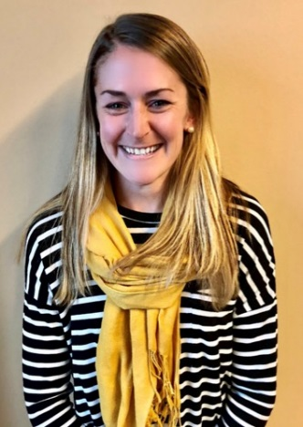

**Katie Carbiener, PT, DPT** - Katie received her DPT from the University of Colorado. Her undergraduate degree in Kinesiology and Biology was earned at Longwood University in Virginia where she also played DI lacrosse. Currently, she pursues her passion of running and enjoys the outdoor recreation CO has to offer from fly fishing, cycling, to mountaineering and climbing. Katie has special interests in gait analysis, sports med and other orthopedic conditions. Her primary philosophy is to empower her patients with the knowledge to better move and use their bodies to reach their personal goals. She is certified in Functional Dry Needling.

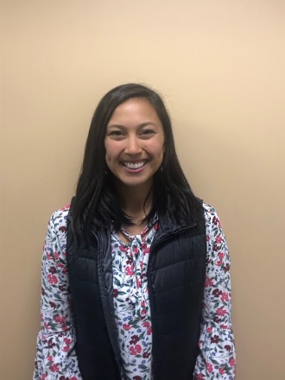**Abby Chris, PT, DPT** - Abby earned her Doctorate of Physical Therapy degree from the University of Colorado, Anschutz Medical Campus in 2019. She earned her Bachelors of Science from Colorado State University-Pueblo. At CSU-Pueblo, she played soccer and found her passion for rehabilitation and return to sport training. She enjoys treating all orthopedic conditions, utilizing a holistic approach to care. Abby strives to provide the best care for her patient’s, incorporating individualized and functional strengthening to help her patient’s get back to what they enjoy! Outside of the clinic she loves everything outdoors, baking, exercising in any form, and spending time with friends and family.

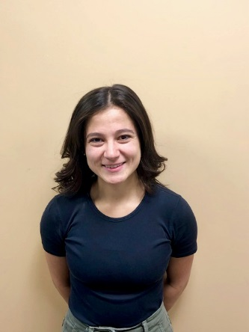**Abigail Ferguson, PT, DPT** - Abigail Ferguson earned her Doctorate in Physical Therapy in 2019 from Regis University with an emphasis in Pelvic Health and Pediatrics. She graduated with honors from Westmont College in 2016 where she studied kinesiology and dance. Her experience in Men and Women’s health and biomechanical research gives her a strong foundation in whole-person care and rehabilitation. She has a passion for promoting pelvic physical therapy in the medical field and treating each patient as an individual.

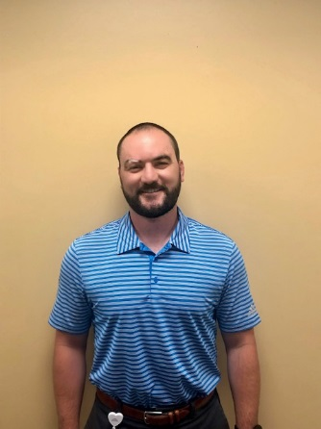

**Matthew Hastings, PT, DPT** - Matt graduated from New York Institute of Technology with his Doctorate of Physical Therapy, and completed his undergraduate degree at the University of Vermont. Matt believes that through an individualized approach to optimizing human performance and movement, he can help his patients maintain a balance of health and wellness. Matt enjoys working with a variety of sports and orthopedic conditions, and he has a passion for injury prevention in weekend warriors and athletes alike. In his free time, Matt enjoys skiing, golfing, hiking, mountain biking and lifting.

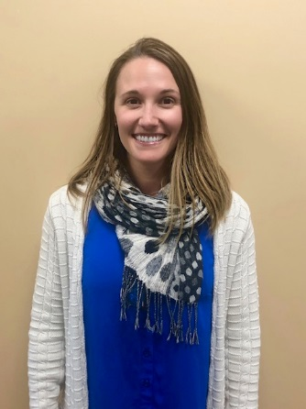**Ayla Olk-Szost, PT, DPT -** Ayla graduated from University of Michigan - Flint with a major in Health Sciences before moving to Florida to earn her Doctor of Physical Therapy from the University of South Florida in 2014. She is a sports clinician and worked with athletes from the high-school, collegiate, and Olympic levels at IMG academy for 4 years before moving to Denver in 2019. She was brought on to the team at Panorama to progress the PRO-formance program that improves the transition from PT to optimal life for our patients. She is Functional Dry Needling Level 1 certified, FMS Level 2 certified, and has extensive experience and education in the areas of manual therapy, posture, sports rehab, and functional training. She loves to teach and believes in centering her care on her patient’s goals and making PT an experience that her patients can learn from and enjoy. Ayla also likes to work out and stay physical with paddle boarding, free-diving, hiking, and exploring Colorado. She likes to balance that activity by going to the movies, reading, and listening to podcasts and would love your recommendations.

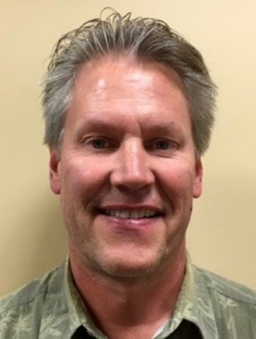**Tom Hermsen, PT, MSPT, CSCS** - A 1983 graduate from the University of Wisconsin – Madison, Tom has been a practicing PT for over 30 years, 27 in outpatient orthopedics. He was a site coordinator and treating therapist at HealthSouth in Lakewood, CO from 1994- 2000. He was the clinic director and practicing PT for Physiotherapy Associates at Golden Ridge for seven years. In 2010, he joined the staff at Panorama Physical Therapy as a senior staff PT. Tom’s area of expertise included the treatment of shoulder and knee dysfunction, and foot and ankle disorders including the fabrication of custom orthotics. He has vast experience in lower extremity biomechanical evaluations. He is also a Certified Strength and Conditioning Specialist (CSCS).

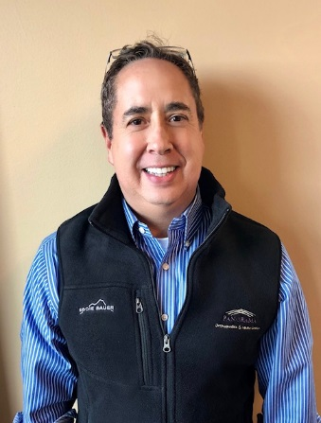**Emery Pino, PT, MSPT** - Emery graduated from the University of Colorado Health Sciences Center Physical Therapy program in 2000. He previously was a System’s Engineer for 13 ½ years, much of the time with IBM. Emery’s engineering background helps him clearly explain pathology to his patients, while using critical thinking to determine the best rehabilitation for complicated patient pathologies and diagnoses. Emery’s interest in physical therapy is in outpatient orthopedics, and is also one of the vestibular and balance therapists at Panorama PT. He has a variety of certifications of continuing education to influence his knowledge and skill base in treating the orthopedic population.

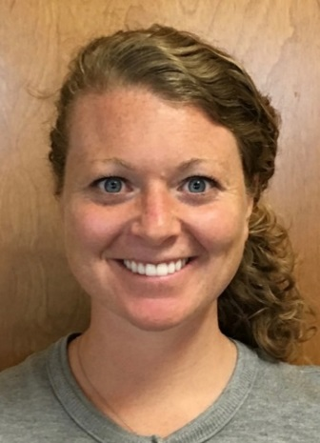

**Kelly Powell, PT, DPT** - Kelly graduated from Stony Brook University with her Doctorate of Physical Therapy in 2012 and completed her undergraduate degree from SUNY Oswego. She enjoys working with all orthopedic conditions and utilizes manual therapy and individualized exercise prescription to assist patients in their recovery. She believes in empowering the patient to reach their goals and prevent re-injury.

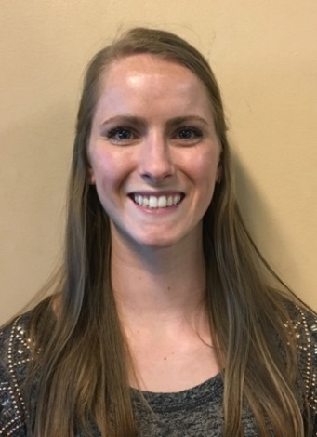

**Kaitlin Thompson, PT, DPT** - Kaitlin graduated from Boston University with a BS in Athletic Training and Doctor of Physical Therapy. Kaitlin started her career in NYC doing outpatient orthopedics with an emphasis on sports/orthopedic rehab and is also a certified vestibular therapist. Her passion in PT lies in using specific exercises and education tailored to each patient to help get them back to what makes them happy. Kaitlin’s happy place is on the volleyball court and up in the mountains. She played club volleyball at BU and continues to play competitively on grass, sand, and indoors.

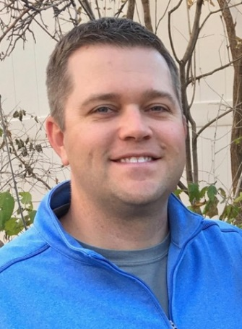**Brad Walters, PT, MSPT, OCS** - Brad graduated in 2002 from the University of Colorado at Boulder, majoring in Kinesiology. He subsequently earned a Master of Science in Physical Therapy from the University Of Colorado Health Sciences Center in 2004. He has been a member of the American Physical Therapy Association and the Orthopedic Section for 15 years. He is a board-certified Orthopedic Clinical Specialist (OCS) since 2012. He was a game-day physical therapist for the NBA's Denver Nuggets for the 2012-2013 season. He was an APTA Orthopedic and Sports Residency Faculty Mentor for ATI Physical Therapy in Greenville, South Carolina from 2014-2017. He is certified in Functional Dry Needling Level 1 and 2 since 2016. He believes in coupling physical therapy with sports performance. He enjoys working within the broad spectrum of orthopedic and sports injuries. He strives to provide a personalized approach to assist each patient in establishing and achieving incremental goals. He combines hands on therapeutic treatment techniques with functional and evidence based exercises that are tailored to both the home and clinic environments. As a Colorado native, Brad enjoys following all his hometown teams, especially the Denver Broncos! He also enjoys golfing, fly-fishing, skiing, traveling and spending time with his wife, Rachael.

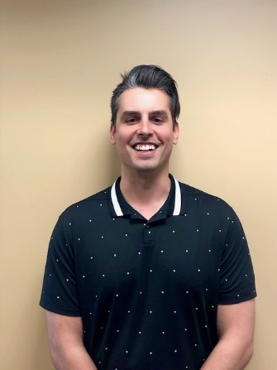**David Whitmore, PT, DPT –** David graduated from Arizona State University’s Barrett Honors College and W.P. Carey School of business in 2014 with a BS in Business Management while also serving as a member of the men’s basketball team. He then attended Baylor University to earn his Doctorate of Physical Therapy in 2019. He enjoys working with a wide array of patient profiles. Whether it is an athlete returning to sport or a patient working to maintain highest functional levels to improve overall quality of life, he wants to be there to help patients meet their goals. He utilizes various manual techniques and evidence-based interventions to progress and improve patient’s functional abilities to return to, if not surpass, their prior level of function. When he is outside of the clinic he enjoys hiking and exploring all of the beauty Colorado has to offer with his wife and their dog Marley.

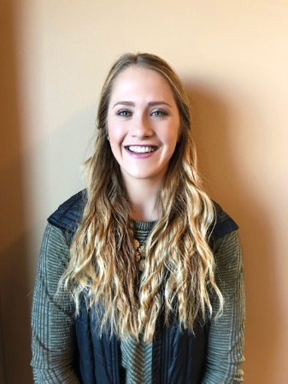**Beth Wood,** **PT, DPT** - Elizabeth (Beth) received her Doctor of Physical Therapy from the University of Colorado, Anschutz Medical Campus in 2018. She earned her Bachelors of Science in Exercise Science from Colorado Mesa University in Grand Junction. Beth is certified in the Selective Functional Movement Assessment (SFMA) and utilizes this treatment approach to identify the cause of discomfort and address biomechanical and neuromuscular dysfunction in her patients. Beth also specializes in pre and post- operative total joint replacement rehab. She treats an array of orthopedic injuries and strives to develop a rapport with patients and make rehab a fun, positive process. Outside of work, Beth enjoys tennis, equestrian events, running, and spending time with friends and family.

**HAND THERAPISTS**

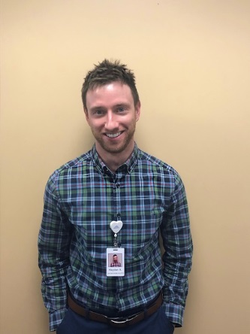

**Hayden Alewine OT, MSOT, OTR/L** - Hayden graduated from the College of Charleston in 2007 with a Bachelor’s in Biology. His desire to help others lead to his subsequent completion of the Master’s program in Occupational Therapy from the Medical University of South Carolina in 2017. His primary focus during graduate school was hand therapy and post-graduation he has continued this focus performing hand therapy while working in outpatient orthopedics in New York. Hayden’s approach to therapy includes helping patients regain functional use of the upper extremity through the use of patient education, exercise, modalities, and other various therapeutic interventions. He is currently in the process of studying to become a Certified Hand Therapist (CHT). In his free time, Hayden enjoys all things outdoors including hiking, biking, camping and fly-fishing.

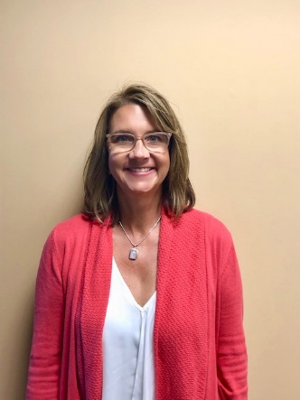**Lisa Condon, OT, MSOT, OTR, CHT** - Lisa graduated from University of Wisconsin-Milwaukee in 1988 with a Bachelor’s in Occupational Therapy. After working 3 years in Inpatient Neurology, she moved to Colorado and pursued Outpatient Orthopedics. She received her Certification in Hand Therapy (CHT) in 1995 and her Master’s in Sports Medicine in 1996. Lisa has a strong passion for treating upper extremity trauma and has spent much of her career developing her manual skills and thoroughly understanding the anatomy of the hand, wrist, elbow and shoulder. She believes that educating the patient on their injury is imperative for a successful outcome and being an active member of the “Hand Team” (MD, Therapist and Patient).